Multiple Linear Regression

# import knitr package - Markdown purpose :  
setwd("C:\\Mugi\\R\\Concrete - Regression")  
  
library(readxl)

library(dplyr)

library(corrplot)

library(caTools)

library(car)

conc_data = read_excel('Concrete_Data.xls')  
  
names(conc_data) = c('cement','blast_furnace_slag','fly_ash','water','superplasticizer','coarse_ggregate', 'fine_aggregate', 'age', 'compressive_strength')  
  
nrow(conc_data)

## [1] 1030

ncol(conc_data)

## [1] 9

str(conc_data)

## Classes 'tbl_df', 'tbl' and 'data.frame': 1030 obs. of 9 variables:  
## $ cement : num 540 540 332 332 199 ...  
## $ blast_furnace_slag : num 0 0 142 142 132 ...  
## $ fly_ash : num 0 0 0 0 0 0 0 0 0 0 ...  
## $ water : num 162 162 228 228 192 228 228 228 228 228 ...  
## $ superplasticizer : num 2.5 2.5 0 0 0 0 0 0 0 0 ...  
## $ coarse_ggregate : num 1040 1055 932 932 978 ...  
## $ fine_aggregate : num 676 676 594 594 826 ...  
## $ age : num 28 28 270 365 360 90 365 28 28 28 ...  
## $ compressive_strength: num 80 61.9 40.3 41.1 44.3 ...

summary(conc_data)

## cement blast_furnace_slag fly_ash water   
## Min. :102.0 Min. : 0.0 Min. : 0.00 Min. :121.8   
## 1st Qu.:192.4 1st Qu.: 0.0 1st Qu.: 0.00 1st Qu.:164.9   
## Median :272.9 Median : 22.0 Median : 0.00 Median :185.0   
## Mean :281.2 Mean : 73.9 Mean : 54.19 Mean :181.6   
## 3rd Qu.:350.0 3rd Qu.:142.9 3rd Qu.:118.27 3rd Qu.:192.0   
## Max. :540.0 Max. :359.4 Max. :200.10 Max. :247.0   
## superplasticizer coarse_ggregate fine_aggregate age   
## Min. : 0.000 Min. : 801.0 Min. :594.0 Min. : 1.00   
## 1st Qu.: 0.000 1st Qu.: 932.0 1st Qu.:731.0 1st Qu.: 7.00   
## Median : 6.350 Median : 968.0 Median :779.5 Median : 28.00   
## Mean : 6.203 Mean : 972.9 Mean :773.6 Mean : 45.66   
## 3rd Qu.:10.160 3rd Qu.:1029.4 3rd Qu.:824.0 3rd Qu.: 56.00   
## Max. :32.200 Max. :1145.0 Max. :992.6 Max. :365.00   
## compressive_strength  
## Min. : 2.332   
## 1st Qu.:23.707   
## Median :34.443   
## Mean :35.818   
## 3rd Qu.:46.136   
## Max. :82.599

#Finding Outlier - cement  
  
boxplot(conc_data$cement)

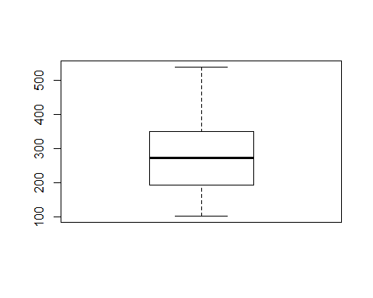

q = quantile(conc_data$cement, probs=c(.25, .75))  
  
lower_boundry = q[1] - (1.5 * IQR(conc_data$cement))  
  
upper_boundry = q[2] + (1.5 * IQR(conc_data$cement))  
  
sum(conc_data$cement > upper_boundry | conc_data$cement < lower_boundry)

## [1] 0

#Finding Outlier - blast_furnace_slag  
  
boxplot(conc_data$blast_furnace_slag)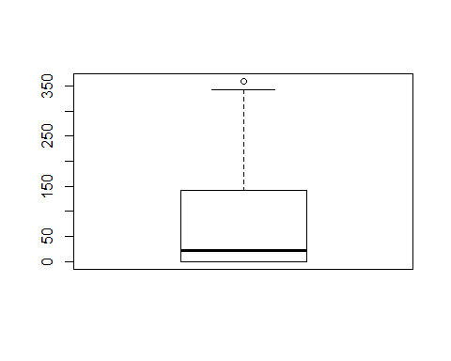

q = quantile(conc_data$blast_furnace_slag, probs=c(.25, .75))  
  
bfs_lower_boundry = q[1] - (1.5 * IQR(conc_data$blast_furnace_slag))  
  
bfs_upper_boundry = q[2] + (1.5 * IQR(conc_data$blast_furnace_slag))  
  
sum(conc_data$blast_furnace_slag > bfs_upper_boundry | conc_data$blast_furnace_slag < bfs_lower_boundry)

## [1] 2

boxplot(conc_data$blast_furnace_slag[conc_data$blast_furnace_slag < bfs_upper_boundry & conc_data$blast_furnace_slag > bfs_lower_boundry])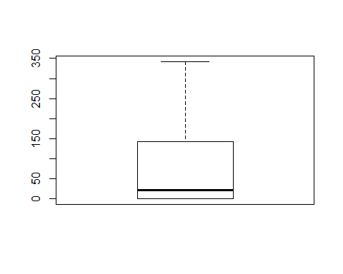

#Finding Outlier - fly_ash  
  
boxplot(conc_data$fly_ash)  
  
q = quantile(conc_data$fly_ash, probs=c(.25, .75))  
  
lower_boundry = q[1] - (1.5 * IQR(conc_data$fly_ash))  
  
upper_boundry = q[2] + (1.5 * IQR(conc_data$fly_ash))  
  
sum(conc_data$fly_ash > upper_boundry | conc_data$fly_ash < lower_boundry)

## [1] 0

boxplot(conc_data$fly_ash[conc_data$fly_ash < upper_boundry & conc_data$fly_ash > lower_boundry])

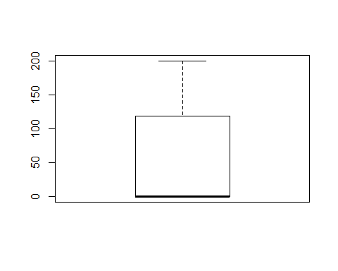

#Finding Outlier - water  
  
boxplot(conc_data$water)

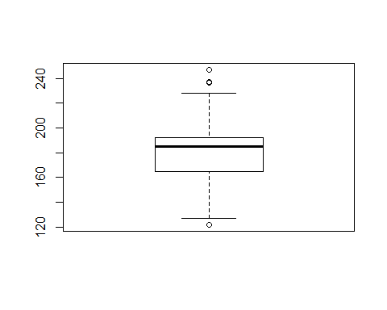

q = quantile(conc_data$water, probs=c(.25, .75))  
  
w_lower_boundry = q[1] - (1.5 * IQR(conc_data$water))  
  
w_upper_boundry = q[2] + (1.5 * IQR(conc_data$water))  
  
sum(conc_data$water > w_upper_boundry | conc_data$water < w_lower_boundry)

## [1] 9

boxplot(conc_data$water[conc_data$water < w_upper_boundry & conc_data$water > w_lower_boundry])

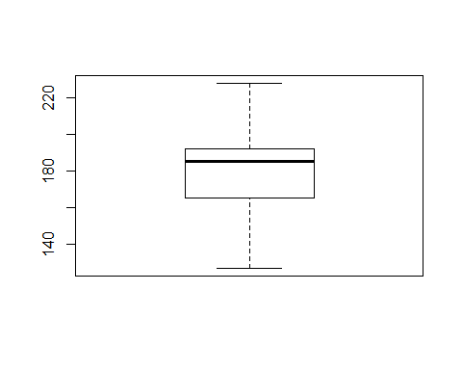

#Finding Outlier - superplasticizer  
  
boxplot(conc_data$superplasticizer)

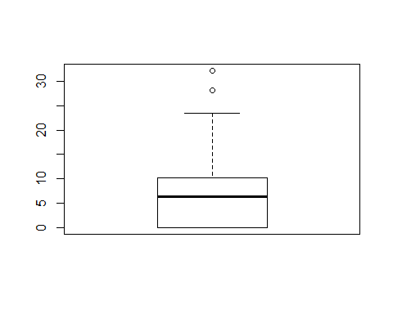

q = quantile(conc_data$superplasticizer, probs=c(.25, .75))  
  
sp_lower_boundry = q[1] - (1.5 * IQR(conc_data$superplasticizer))  
  
sp_upper_boundry = q[2] + (1.5 * IQR(conc_data$superplasticizer))  
  
sum(conc_data$superplasticizer > sp_upper_boundry | conc_data$superplasticizer < sp_lower_boundry)

## [1] 10

boxplot(conc_data$superplasticizer[conc_data$superplasticizer < sp_upper_boundry & conc_data$superplasticizer > sp_lower_boundry])

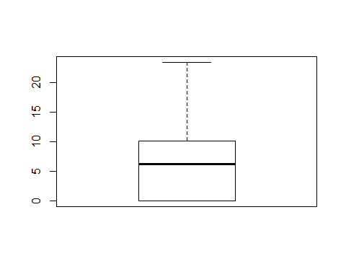

#Finding Outlier - coarse_ggregate  
  
boxplot(conc_data$coarse_ggregate)  
  
q = quantile(conc_data$coarse_ggregate, probs=c(.25, .75))  
  
lower_boundry = q[1] - (1.5 * IQR(conc_data$coarse_ggregate))  
  
upper_boundry = q[2] + (1.5 * IQR(conc_data$coarse_ggregate))  
  
sum(conc_data$coarse_ggregate > upper_boundry | conc_data$coarse_ggregate < lower_boundry)

## [1] 0

boxplot(conc_data$coarse_ggregate[conc_data$coarse_ggregate < upper_boundry & conc_data$coarse_ggregate > lower_boundry])

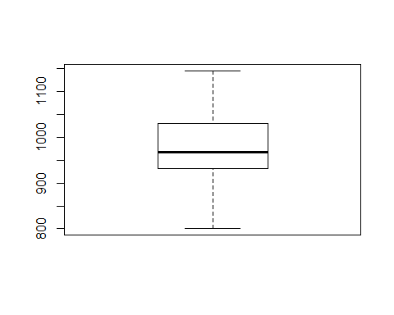

#Finding Outlier - fine_aggregate  
  
boxplot(conc_data$fine_aggregate)

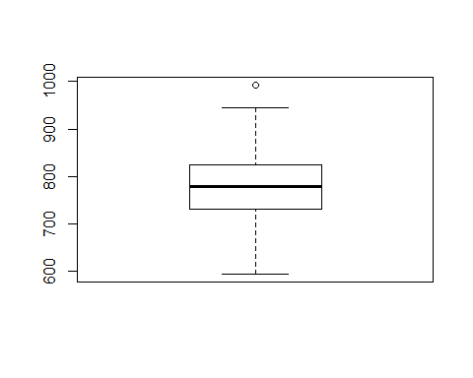

q = quantile(conc_data$fine_aggregate, probs=c(.25, .75))  
  
fa_lower_boundry = q[1] - (1.5 * IQR(conc_data$fine_aggregate))  
  
fa_upper_boundry = q[2] + (1.5 * IQR(conc_data$fine_aggregate))  
  
sum(conc_data$fine_aggregate > fa_upper_boundry | conc_data$fine_aggregate < fa_lower_boundry)

## [1] 5

boxplot(conc_data$fine_aggregate[conc_data$fine_aggregate < fa_upper_boundry & conc_data$fine_aggregate > fa_lower_boundry])

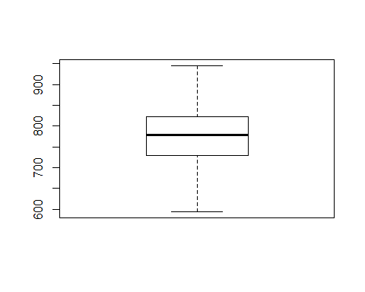

#Finding Outlier - age  
  
boxplot(conc_data$age)

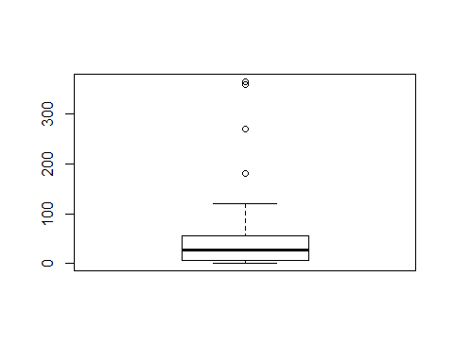

q = quantile(conc_data$age, probs=c(.25, .75))  
  
age_lower_boundry = q[1] - (1.5 * IQR(conc_data$age))  
  
age_upper_boundry = q[2] + (1.5 * IQR(conc_data$age))  
  
sum(conc_data$age > age_upper_boundry | conc_data$age < age_lower_boundry)

## [1] 59

boxplot(conc_data$age[conc_data$age < age_upper_boundry & conc_data$age > age_lower_boundry])

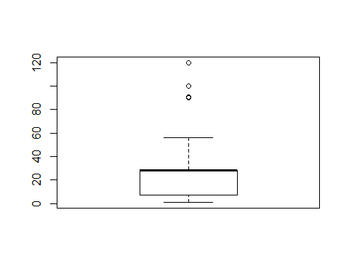

hist(conc_data$age[conc_data$age < age_upper_boundry & conc_data$age > age_lower_boundry])

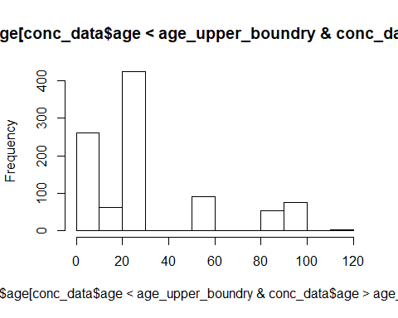

sum(conc_data$age > 80)

## [1] 190

summary(conc_data$age)

## Min. 1st Qu. Median Mean 3rd Qu. Max.   
## 1.00 7.00 28.00 45.66 56.00 365.00

age_v1 = conc_data$age[conc_data$age < age_upper_boundry & conc_data$age > age_lower_boundry]  
  
  
q = quantile(age_v1, probs=c(.25, .75))  
  
age_lower_boundry_v1 = q[1] - (1.5 * IQR(age_v1))  
  
age_upper_boundry_v1 = q[2] + (1.5 * IQR(age_v1))  
  
sum(conc_data$age > age_upper_boundry_v1 | conc_data$age < age_lower_boundry_v1)

## [1] 190

boxplot(conc_data$age[conc_data$age < age_upper_boundry_v1 & conc_data$age > age_lower_boundry_v1])

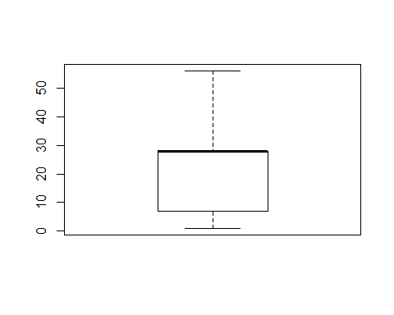

hist(conc_data$age[conc_data$age < age_upper_boundry_v1 & conc_data$age > age_lower_boundry_v1])

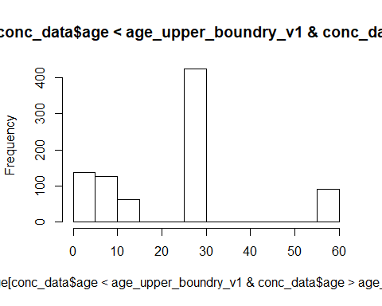

#Finding Outlier - Dependent Variable - compressive_strength  
  
boxplot(conc_data$compressive_strength)

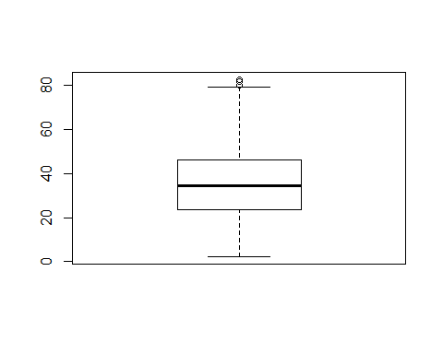

q = quantile(conc_data$compressive_strength, probs=c(.25, .75))  
  
lower_boundry = q[1] - (1.5 * IQR(conc_data$compressive_strength))  
  
upper_boundry = q[2] + (1.5 * IQR(conc_data$compressive_strength))  
  
sum(conc_data$compressive_strength > upper_boundry | conc_data$compressive_strength < lower_boundry)

## [1] 4

boxplot(conc_data$compressive_strength[conc_data$compressive_strength < upper_boundry & conc_data$compressive_strength > lower_boundry])

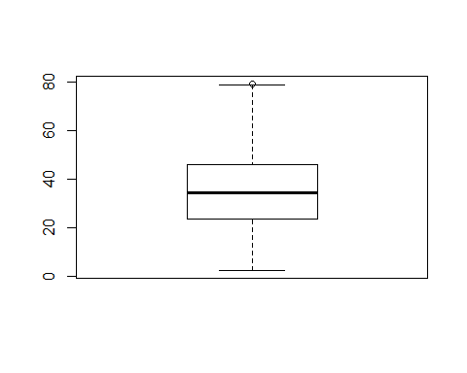

# Removing outliers from dataset - (only Independent variables)  
  
conc_data_clean = filter(conc_data, (blast_furnace_slag > bfs_lower_boundry & blast_furnace_slag < bfs_upper_boundry)  
 & (water > w_lower_boundry & water < w_upper_boundry)  
 & (superplasticizer > sp_lower_boundry & superplasticizer < sp_upper_boundry)  
 & (fine_aggregate > fa_lower_boundry & fine_aggregate < fa_upper_boundry)  
 & (age > age_lower_boundry_v1 & age < age_upper_boundry_v1))  
  
  
  
boxplot(conc_data_clean)

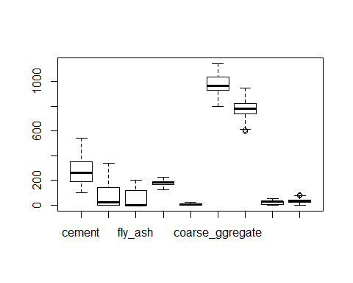

summary(conc_data_clean)

## cement blast_furnace_slag fly_ash water   
## Min. :102.0 Min. : 0.00 Min. : 0.00 Min. :127.0   
## 1st Qu.:190.3 1st Qu.: 0.00 1st Qu.: 0.00 1st Qu.:164.9   
## Median :263.2 Median : 22.00 Median : 0.00 Median :183.0   
## Mean :276.5 Mean : 74.77 Mean : 59.53 Mean :180.2   
## 3rd Qu.:349.0 3rd Qu.:145.00 3rd Qu.:118.90 3rd Qu.:192.0   
## Max. :540.0 Max. :342.10 Max. :200.10 Max. :228.0   
## superplasticizer coarse_ggregate fine_aggregate age   
## Min. : 0.000 Min. : 801.0 Min. :594.0 Min. : 1.00   
## 1st Qu.: 0.000 1st Qu.: 931.0 1st Qu.:736.1 1st Qu.: 7.00   
## Median : 7.000 Median : 968.0 Median :778.5 Median :28.00   
## Mean : 6.431 Mean : 973.3 Mean :774.9 Mean :22.76   
## 3rd Qu.:10.370 3rd Qu.:1036.8 3rd Qu.:820.8 3rd Qu.:28.00   
## Max. :22.100 Max. :1145.0 Max. :945.0 Max. :56.00   
## compressive_strength  
## Min. : 2.332   
## 1st Qu.:20.981   
## Median :31.730   
## Mean :33.088   
## 3rd Qu.:42.391   
## Max. :81.751

#EDA  
  
cor_matrix = cor(conc_data)  
  
corrplot(cor_matrix)

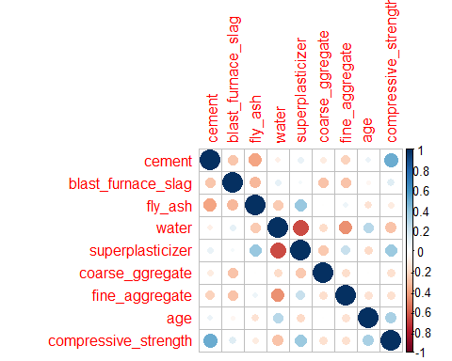

cor_matrix_clean = cor(conc_data_clean)  
  
corrplot(cor_matrix_clean)

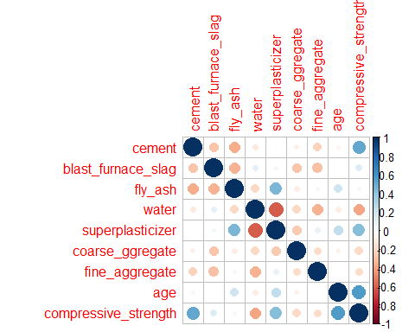

#Correlation between independent and dependent variables  
  
ggplot(conc_data_clean, aes(x=cement, y=compressive_strength)) + geom_point() + geom_smooth(method=lm)

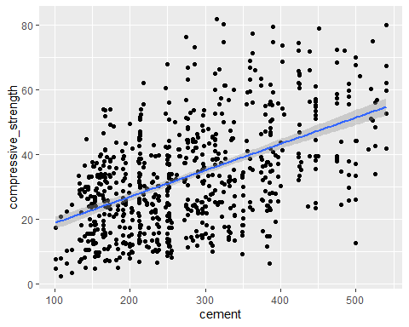

#Inference - Cement has positive correlation with comprehensive strengrh - when amount of cement increase, we can see the increase of strength

ggplot(conc_data_clean, aes(x=blast_furnace_slag, y=compressive_strength)) + geom_point() + geom_smooth(method=lm)

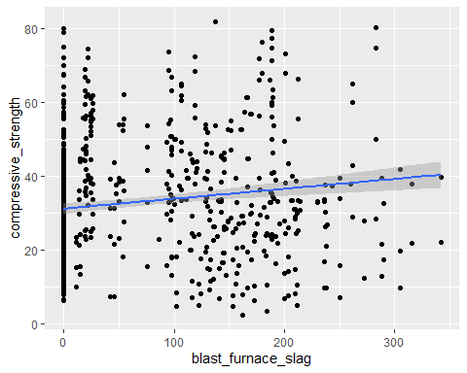

#Inference - no relation between blast_furnace_slag and compressive_strength

ggplot(conc_data_clean, aes(x=fly_ash, y=compressive_strength)) + geom_point() + geom_smooth(method=lm)

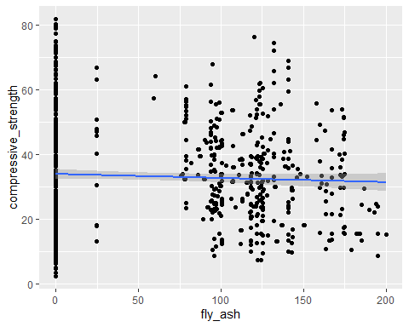

#Inference - no relation between fly_ash and compressive_strength

ggplot(conc_data_clean, aes(x=water, y=compressive_strength)) + geom_point() + geom_smooth(method=lm)

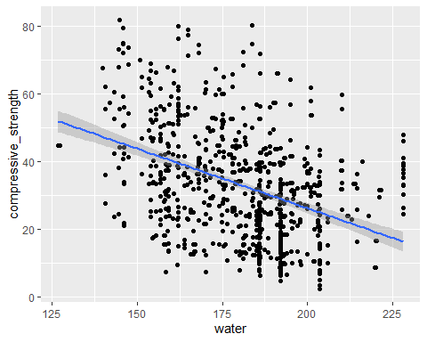

#Inference - There is a negative correlation between water and compressive_strength

ggplot(conc_data_clean, aes(x=superplasticizer, y=compressive_strength)) + geom_point() + geom_smooth(method=lm)

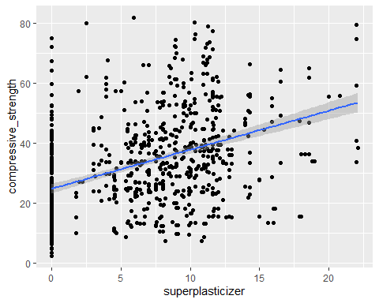

#Inference - We can see a positve correlation between superplasticizer and compressive_strength

ggplot(conc_data_clean, aes(x=coarse_ggregate, y=compressive_strength)) + geom_point() + geom_smooth(method=lm)

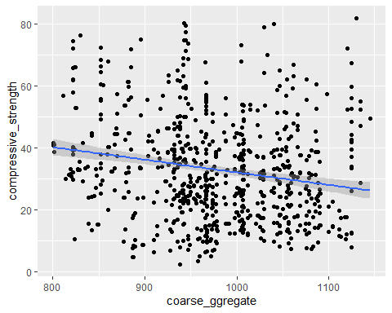

#Inference - Very less negative correlation between coarse_ggregate and compressive_strength

ggplot(conc_data_clean, aes(x=fine_aggregate, y=compressive_strength)) + geom_point() + geom_smooth(method=lm)

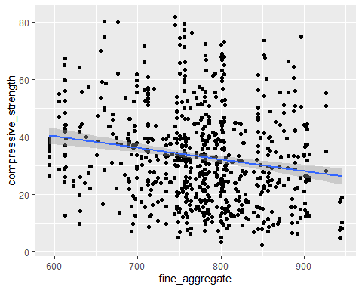

#Inference - Very less negative correlation between fine_aggregate and compressive_strength

#Correlation between independent variables - to check multicollinearity

ggplot(conc_data_clean, aes(x=water, y=superplasticizer)) + geom_point() + geom_smooth(method=lm)

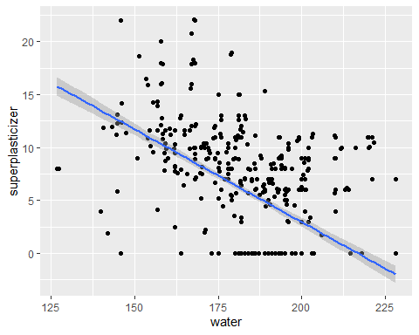

#Inference - water is negatively correlated with superplasticizer - This is as per the fact that superplasticizer is used to reduce water quantity in concrete

ggplot(conc_data_clean, aes(x=fly_ash, y=superplasticizer)) + geom_point() + geom_smooth(method=lm)

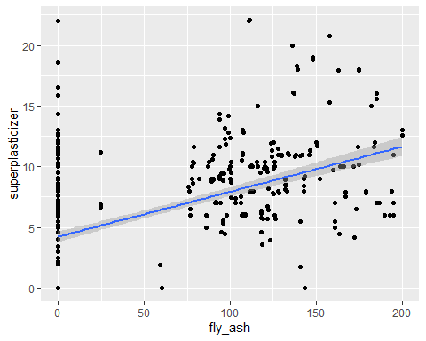

#Inference - fly_ash has positive correlation with superplasticizer, which may result in multicollinearity

hist(conc_data_clean$cement)

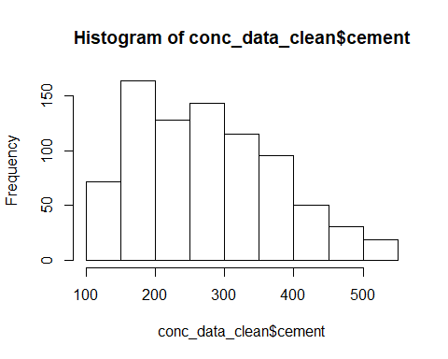

hist(conc_data_clean$blast_furnace_slag)

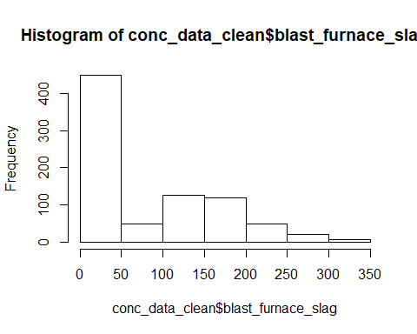

hist(conc_data_clean$fly_ash)

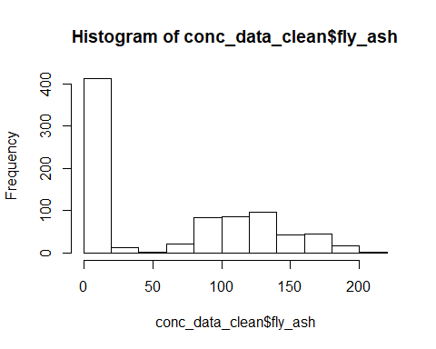

hist(conc_data_clean$water)

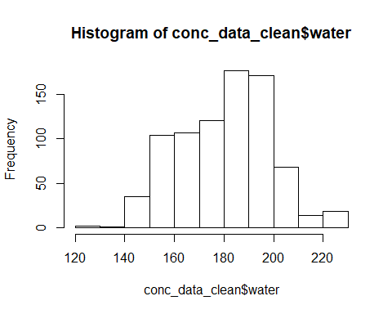

hist(conc_data_clean$superplasticizer)

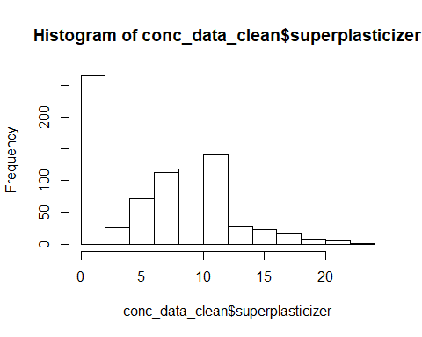

hist(conc_data_clean$coarse_ggregate)

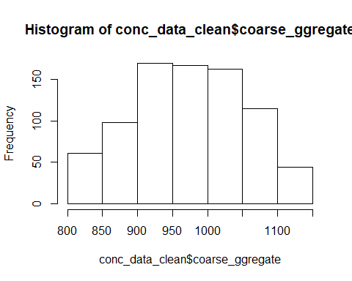

hist(conc_data_clean$fine_aggregate)

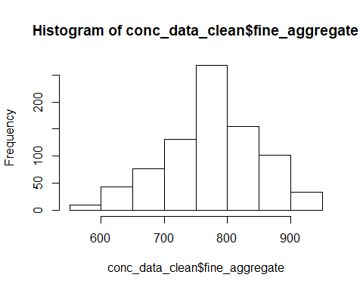

hist(conc_data_clean$age)

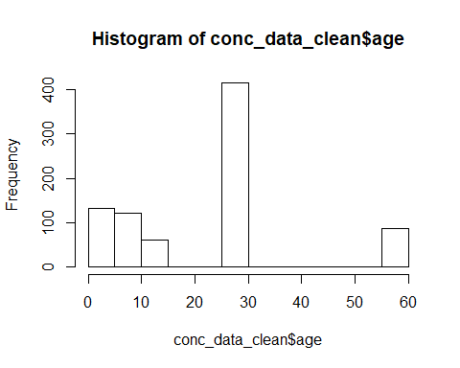

hist(log(conc_data_clean$age))

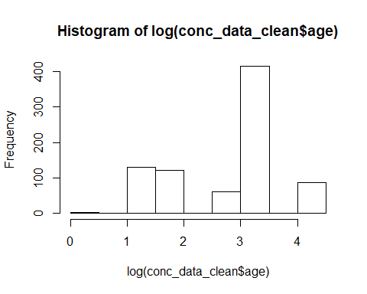

hist(sqrt(conc_data_clean$age))

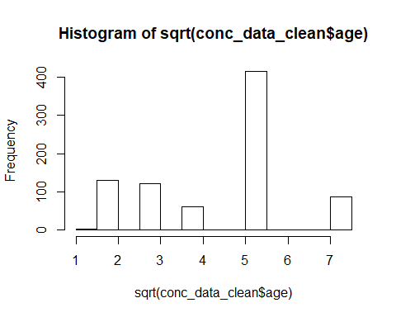

hist(conc_data_clean$compressive_strength)

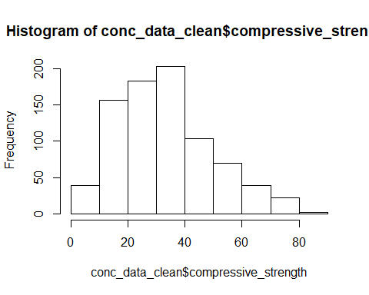

names(conc_data_clean)

## [1] "cement" "blast_furnace_slag" "fly_ash"   
## [4] "water" "superplasticizer" "coarse_ggregate"   
## [7] "fine_aggregate" "age" "compressive_strength"

#Test and Train Data Split  
  
  
set.seed(123) # set seed to ensure you always have same random numbers generated  
  
sample = sample.split(conc_data_clean,SplitRatio = 0.80)   
  
train_data =subset(conc_data_clean,sample ==TRUE)

## Warning: Length of logical index must be 1 or 818, not 9

test_data =subset(conc_data_clean,sample ==FALSE)

## Warning: Length of logical index must be 1 or 818, not 9

linear_eq = lm(compressive_strength ~ cement + blast_furnace_slag + fly_ash + water + superplasticizer + coarse_ggregate + fine_aggregate + age, data = train_data)  
  
summary(linear_eq)

##   
## Call:  
## lm(formula = compressive_strength ~ cement + blast_furnace_slag +   
## fly_ash + water + superplasticizer + coarse_ggregate + fine_aggregate +   
## age, data = train_data)  
##   
## Residuals:  
## Min 1Q Median 3Q Max   
## -21.2350 -4.1800 -0.2122 3.6752 31.0660   
##   
## Coefficients:  
## Estimate Std. Error t value Pr(>|t|)   
## (Intercept) 19.6655530 24.5033848 0.803 0.423   
## cement 0.1109035 0.0075882 14.615 < 2e-16 ***  
## blast_furnace_slag 0.0810362 0.0091603 8.846 < 2e-16 ***  
## fly_ash 0.0457349 0.0111808 4.090 4.87e-05 ***  
## water -0.2237279 0.0379983 -5.888 6.38e-09 ***  
## superplasticizer 0.0465466 0.0947029 0.492 0.623   
## coarse_ggregate 0.0006942 0.0086228 0.081 0.936   
## fine_aggregate 0.0009541 0.0097521 0.098 0.922   
## age 0.5590634 0.0196533 28.446 < 2e-16 ***  
## ---  
## Signif. codes: 0 '***' 0.001 '**' 0.01 '*' 0.05 '.' 0.1 ' ' 1  
##   
## Residual standard error: 7.285 on 627 degrees of freedom  
## Multiple R-squared: 0.8048, Adjusted R-squared: 0.8023   
## F-statistic: 323.2 on 8 and 627 DF, p-value: < 2.2e-16

#VIF - Variance Inflation Factor to check Multicollinearity  
  
vif(linear_eq)

## cement blast_furnace_slag fly_ash water   
## 7.271422 7.609270 6.221441 5.778825   
## superplasticizer coarse_ggregate fine_aggregate age   
## 3.005247 5.661650 6.155691 1.086282

linear_eq_v1 = lm(compressive_strength ~ cement + fly_ash + water + superplasticizer + coarse_ggregate + fine_aggregate + age, data = train_data)  
  
summary(linear_eq_v1)

##   
## Call:  
## lm(formula = compressive_strength ~ cement + fly_ash + water +   
## superplasticizer + coarse_ggregate + fine_aggregate + age,   
## data = train_data)  
##   
## Residuals:  
## Min 1Q Median 3Q Max   
## -26.142 -4.533 -0.616 4.435 33.113   
##   
## Coefficients:  
## Estimate Std. Error t value Pr(>|t|)   
## (Intercept) 205.142752 13.439230 15.264 < 2e-16 ***  
## cement 0.051167 0.003668 13.949 < 2e-16 ***  
## fly_ash -0.039893 0.005931 -6.726 3.92e-11 ***  
## water -0.444505 0.030365 -14.639 < 2e-16 ***  
## superplasticizer 0.021811 0.100316 0.217 0.828   
## coarse_ggregate -0.061522 0.005287 -11.637 < 2e-16 ***  
## fine_aggregate -0.072781 0.005365 -13.565 < 2e-16 ***  
## age 0.551591 0.020808 26.509 < 2e-16 ***  
## ---  
## Signif. codes: 0 '***' 0.001 '**' 0.01 '*' 0.05 '.' 0.1 ' ' 1  
##   
## Residual standard error: 7.72 on 628 degrees of freedom  
## Multiple R-squared: 0.7804, Adjusted R-squared: 0.778   
## F-statistic: 318.9 on 7 and 628 DF, p-value: < 2.2e-16

vif(linear_eq_v1)

## cement fly_ash water superplasticizer   
## 1.513077 1.558731 3.286052 3.002627   
## coarse_ggregate fine_aggregate age   
## 1.895264 1.659050 1.084275

linear_eq_v1_1 = lm(compressive_strength ~ cement + fly_ash + water + superplasticizer + coarse_ggregate + fine_aggregate + age, data = train_data)  
  
summary(linear_eq_v1_1)

##   
## Call:  
## lm(formula = compressive_strength ~ cement + fly_ash + water +   
## superplasticizer + coarse_ggregate + fine_aggregate + age,   
## data = train_data)  
##   
## Residuals:  
## Min 1Q Median 3Q Max   
## -26.142 -4.533 -0.616 4.435 33.113   
##   
## Coefficients:  
## Estimate Std. Error t value Pr(>|t|)   
## (Intercept) 205.142752 13.439230 15.264 < 2e-16 ***  
## cement 0.051167 0.003668 13.949 < 2e-16 ***  
## fly_ash -0.039893 0.005931 -6.726 3.92e-11 ***  
## water -0.444505 0.030365 -14.639 < 2e-16 ***  
## superplasticizer 0.021811 0.100316 0.217 0.828   
## coarse_ggregate -0.061522 0.005287 -11.637 < 2e-16 ***  
## fine_aggregate -0.072781 0.005365 -13.565 < 2e-16 ***  
## age 0.551591 0.020808 26.509 < 2e-16 ***  
## ---  
## Signif. codes: 0 '***' 0.001 '**' 0.01 '*' 0.05 '.' 0.1 ' ' 1  
##   
## Residual standard error: 7.72 on 628 degrees of freedom  
## Multiple R-squared: 0.7804, Adjusted R-squared: 0.778   
## F-statistic: 318.9 on 7 and 628 DF, p-value: < 2.2e-16

vif(linear_eq_v1_1)

## cement fly_ash water superplasticizer   
## 1.513077 1.558731 3.286052 3.002627   
## coarse_ggregate fine_aggregate age   
## 1.895264 1.659050 1.084275

linear_eq_v2 = lm(compressive_strength ~ cement + fly_ash + water + coarse_ggregate + fine_aggregate + age, data = train_data)  
  
summary(linear_eq_v2)

##   
## Call:  
## lm(formula = compressive_strength ~ cement + fly_ash + water +   
## coarse_ggregate + fine_aggregate + age, data = train_data)  
##   
## Residuals:  
## Min 1Q Median 3Q Max   
## -26.246 -4.502 -0.619 4.412 33.046   
##   
## Coefficients:  
## Estimate Std. Error t value Pr(>|t|)   
## (Intercept) 207.076095 10.069271 20.565 < 2e-16 ***  
## cement 0.051075 0.003641 14.027 < 2e-16 ***  
## fly_ash -0.039494 0.005635 -7.009 6.19e-12 ***  
## water -0.449265 0.021022 -21.371 < 2e-16 ***  
## coarse_ggregate -0.062167 0.004374 -14.213 < 2e-16 ***  
## fine_aggregate -0.073193 0.005015 -14.595 < 2e-16 ***  
## age 0.552197 0.020605 26.799 < 2e-16 ***  
## ---  
## Signif. codes: 0 '***' 0.001 '**' 0.01 '*' 0.05 '.' 0.1 ' ' 1  
##   
## Residual standard error: 7.714 on 629 degrees of freedom  
## Multiple R-squared: 0.7804, Adjusted R-squared: 0.7783   
## F-statistic: 372.6 on 6 and 629 DF, p-value: < 2.2e-16

vif(linear_eq_v2)

## cement fly_ash water coarse_ggregate fine_aggregate   
## 1.493213 1.409038 1.577335 1.299134 1.451750   
## age   
## 1.064825

linear_eq_v3 = lm(compressive_strength ~ cement + fly_ash + superplasticizer + coarse_ggregate + fine_aggregate + age, data = train_data)  
  
summary(linear_eq_v3)

##   
## Call:  
## lm(formula = compressive_strength ~ cement + fly_ash + superplasticizer +   
## coarse_ggregate + fine_aggregate + age, data = train_data)  
##   
## Residuals:  
## Min 1Q Median 3Q Max   
## -23.723 -5.131 -0.853 4.704 42.226   
##   
## Coefficients:  
## Estimate Std. Error t value Pr(>|t|)   
## (Intercept) 29.817347 7.054734 4.227 2.72e-05 ***  
## cement 0.070157 0.003970 17.670 < 2e-16 ***  
## fly_ash -0.039095 0.006863 -5.697 1.88e-08 ***  
## superplasticizer 1.080738 0.080426 13.438 < 2e-16 ***  
## coarse_ggregate -0.011847 0.004691 -2.525 0.0118 *   
## fine_aggregate -0.027845 0.005092 -5.468 6.56e-08 ***  
## age 0.548709 0.024078 22.789 < 2e-16 ***  
## ---  
## Signif. codes: 0 '***' 0.001 '**' 0.01 '*' 0.05 '.' 0.1 ' ' 1  
##   
## Residual standard error: 8.934 on 629 degrees of freedom  
## Multiple R-squared: 0.7055, Adjusted R-squared: 0.7027   
## F-statistic: 251.2 on 6 and 629 DF, p-value: < 2.2e-16

vif(linear_eq_v3)

## cement fly_ash superplasticizer coarse_ggregate   
## 1.323821 1.558599 1.441288 1.114468   
## fine_aggregate age   
## 1.115964 1.084178

#MAPE - Mean Absolute Percentage Error - linear_eq_v3  
  
model_result = predict(linear_eq_v3, test_data[,c('cement','fly_ash','superplasticizer','coarse_ggregate','fine_aggregate','age')])  
  
  
model_result= as.data.frame(model_result)  
  
output <- cbind(test_data, model_result)  
  
output$diff = output$compressive_strength - output$model_result  
  
output$error = abs(output$diff/ output$compressive_strength)* 100  
  
MAPE<-mean(output$error)  
  
MAPE

## [1] 29.94019

#MAPE - Mean Absolute Percentage Error - linear_eq_v2  
  
model_result = predict(linear_eq_v2, test_data[,c('cement','fly_ash','water','coarse_ggregate','fine_aggregate','age')])  
  
  
model_result= as.data.frame(model_result)  
  
output <- cbind(test_data, model_result)  
  
output$diff = output$compressive_strength - output$model_result  
  
output$error = abs(output$diff/ output$compressive_strength)* 100  
  
MAPE<-mean(output$error)  
  
MAPE

## [1] 23.61674

#MAPE - Mean Absolute Percentage Error - linear_eq  
  
model_result = predict(linear_eq, test_data[,c('cement','blast_furnace_slag','fly_ash','water', 'superplasticizer','coarse_ggregate','fine_aggregate','age')])  
  
  
model_result= as.data.frame(model_result)  
  
output <- cbind(test_data, model_result)  
  
output$diff = output$compressive_strength - output$model_result  
  
output$error = abs(output$diff/ output$compressive_strength)* 100  
  
MAPE<-mean(output$error)  
  
MAPE

## [1] 21.11366